
Darom / STEM Doctoral Fellowships Checklist
☐ Darom (For the direct track only)
☒ STEM (new excellent applicants for STEM research)

- A PDF File Including:
  - Signed checklist
  - Application Form
  - Final grade of bachelor’s degree
  - Final grade sheets MA degree
  - Student ranking in the Bachelor’s degree.
- Excel file in English (to be submitted as a separate file)

If you have an upcoming publication, include:
- Acceptance letter from the journal confirming the manuscript's status for manuscripts “in press”
- Preprint of submitted manuscripts
- Draft of manuscripts in preparation

Name and signature of the applicant (confirming completeness and accuracy)
Name | Roy-Israel Prishkulnik | signature

Name and signature of the advisor (confirming academic review and approval)
Name | Moshe Schechter | signature | 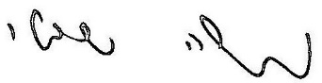

Name and signature of the department/faculty representative (confirming final administrative review and approval)
Name |  | signature

